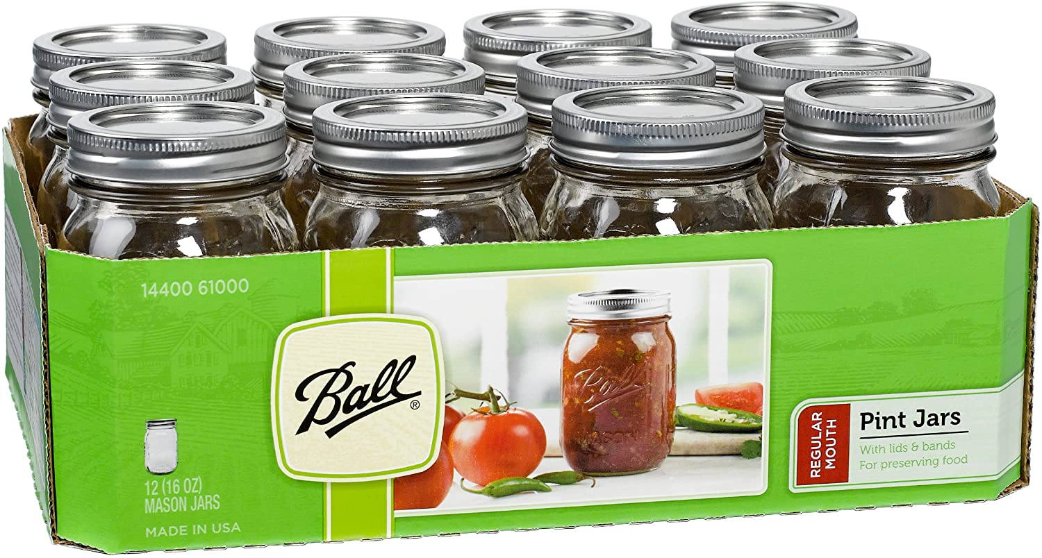

https://i.imgur.com/tSgKHgr.jpg